EVALUATION OF UTILIZING SERVICE ORIENTED ARCHITECTURE AS A SUITABLE SOLUTION TO ALIGN UNIVERSITY MANAGEMENT INFORMATION SYSTEMS AND LEARNING MANAGEMENT SYSTEMS
A. M. RIAD,
Head of Information Systems Department,
Faculty of Computers and Information Sciences,
Mansoura University, EGYPT
Hamdy K. EL-MINIR
National Research Institute of Astronomy
and Geophysics, Helwan, EGYPT
Haitham A. EL-GHAREEB
Faculty of Computers and Information Sciences,
Mansoura City University, EGYPT

ABSTRACT

To help universities achieve their goals, it is important to align managerial functionalities side by side with educational aspects. Universities consume University Management Information Systems (UMIS) to handle managerial aspects as they do with Learning Management Systems (LMS) to achieve learning objectives. UMIS advances LMS by decades and has reached stable and mature consistency level. LMS is the newly acquired solution in Universities; compared to UMIS, and so adopting LMSs in universities can be achieved via three different deployment approaches. First approach believes in LMS ability to replace UMIS and performing its functionalities.

Second approach presents the idea of extending UMIS to include LMS functionalities. Third approach arises from the shortages of the two proposed approaches and present integration between both as the appropriate deployment approach. Service Oriented Architecture (SOA) is a design pattern that can be used as a suitable architectural solution to align UMIS and LMS. SOA can be utilized in universities to overcome some of information systems’ challenges like the integration between UMIS and LMS.

This paper presents the current situation at Mansoura University; Egypt, presents integration as the most suitable solution, and evaluates three different implementation techniques: Dynamic Query, Stored Procedure, and Web services. Evaluation concludes that though SOA enhanced many different aspects of both UMIS and LMS; and consequently university overall. It is not recommended to adopt SOA via Web services as the building unit of the system, but as the interdisciplinary interface between systems.

Keywords: University Management Information System, Learning Management System, e-Learning, Service Oriented Architecture

INTRODUCTION AND OBJECTIVES

E-Learning has been widely used to refer to computer based systems that not necessarily help main objectives of learning. UMIS is not the appropriate solution to support e-Learning; because it is not based on philosophical theories of learning. Also, LMS shall not focus intensively on managerial aspects of the university and focus on learning objectives. LMS is the software that automates the administration of training, as it registers users, tracks courses in a catalog, records data from learners, and provides reports to management. On the other hand, UMIS is the software that automates Students Affairs and Youth departments’ activities in the university. They both complete each other, with the fact that UMIS advances LMS by decades.

Surveying Open source, free, and commercial LMSs yield the fact that LMSs tend to present enough managerial activities to the extent that makes them a standalone solution for universities. While Mansoura University has its own in house developed and deployed solution to manage university activities, adopting LMS as a replacement is not accepted. A solution to integrating UMIS and LMS via portals was presented in (Klims 2007). Though university portals can present a solution to the current situation, it is considered a missing solution because systems are not really integrated on application level but are integrated on user level. So, applications are still isolated islands that need to exchange data between each other. There is a real need of loose coupling in LMS and it will be of high importance in the near future (Kunkel 2006).

This paper goes as follow: section two presents a description of the current situation in Mansoura University, concluding with the importance of integrating both UMIS and LMS as the only suitable solution. Section three presents the evaluation of proposed solution from both information system quality parameters and pedagogical point of view. Section four concludes the paper and presents future work. Paper ends by references.

DESCRIPTION OF THE CURRENT SITUATION AND PROPOSED SOLUTION

Mansoura University runs its in house developed and deployed UMIS for more than a decade right now. UMIS has reached a stable and well mature state when compared to the newly introduced LMS in the university. To adopt LMS functionalities in the University; without making LMS and UMIS isolated islands, there are three deployment approaches to choose from:

- Approach One (LMS replaces UMIS): University will replace its UMIS with LMS that will perform both educational and managerial functions. Challenges are: UMIS has been customized to fit University rules and regulations and it is not easy to let it go simply, importing current data into LMS might be a challenge, and there is a risk of system inconvenience especially if LMS failed to provide managerial functionalities the way UMIS do.
- Approach Two (UMIS takes over LMS): University will add learning functionalities to current UMIS. Though this approach overcomes shortages of previous one but still has some challenges to manage, like time to develop and add the new features while university can make use of advanced features available right now via LMS providers, and dealing with emerging standards.
- Approach Three (Integrate UMIS and LMS): Neither LMS will replace UMIS nor UMIS will take over LMS. Both UMIS and LMS will exist and interoperate to enable university to achieve its managerial and educational tasks in efficient and effective manner. This alternative avoids all challenges presented in alternatives one and two. It avoids replacing UMIS risks, and provides flexibility to change LMS without affecting UMIS, and provides an immediate solution to make use of current available LMS functionalities.

Approach three presents the most suitable solution to the current situation with technical challenges to integrate different information systems side by side while keeping in mind that different information systems require different information presentation for the same entity. Student is an example of the entities that require different information presentations. Student data required by UMIS differ than student learning profile needed by LMS (Britain and Liber 2008). UMIS student record includes data like ID, Social Security Number (SSN), name, age, gender, address (street, city, country), email, username, password, Date of Birth (DOB), faculty, year, department while LMS student profile include data like a detailed records of what students have already learned at the level of learning objects, a learning preferences profile, and a development portfolio of transferable skills, a history of student interactions with tutors, peers, and other significant learning activities (Riad and El-Ghareeb 2007).

Current IT Infrastructure
Figure 1 presents the current scenario in Mansoura University; where users can be classified into UMIS users; to handle non-educational activities, and LMS users; to handle educational activities. To generate a detailed report of the courses and the learning contents, the user has to go through UMIS to generate the courses IDs and LMS to acquire the learning content. UMIS and LMS are isolated islands connected only via users. The assessment experience by Faculty of Computers and Information Sciences in Mansoura University; http://www.m-assessment.info highlighted many of the challenges exist in the University. Assessment Management System (AMS) team asked students to register explicitly for the AMS; and that is not accepted. A single-student registration is a must to satisfy all learning interactions with the University.

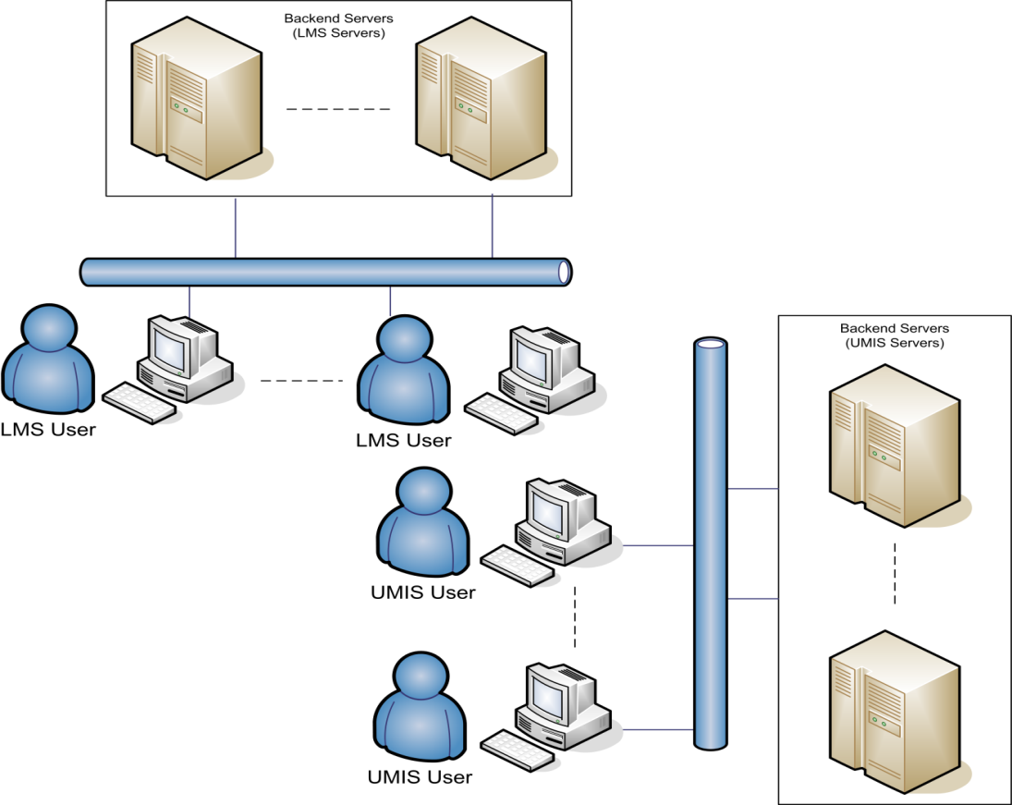

Figure: 1
Current Scenario (Isolated UMIS and LMS integrated via users)

Proposed IT Modifications
Figure 2 presents the proposed solution where a Service Layer shall be added in the middle area between UMIS, LMS, and users. Middle layer facilitates integration between different systems via Web services. Web services are relatively a new technology that have received wide acceptance as an important implementation of SOA (Endrei 2004). Middle layer can provide portal(s) to unify users’ interaction with different systems. More information about proposed Course Management System (CMS) can be found in (Riad and El-Ghareeb 2007) and AMS can be found in (Riad and El-Ghareeb 2008).
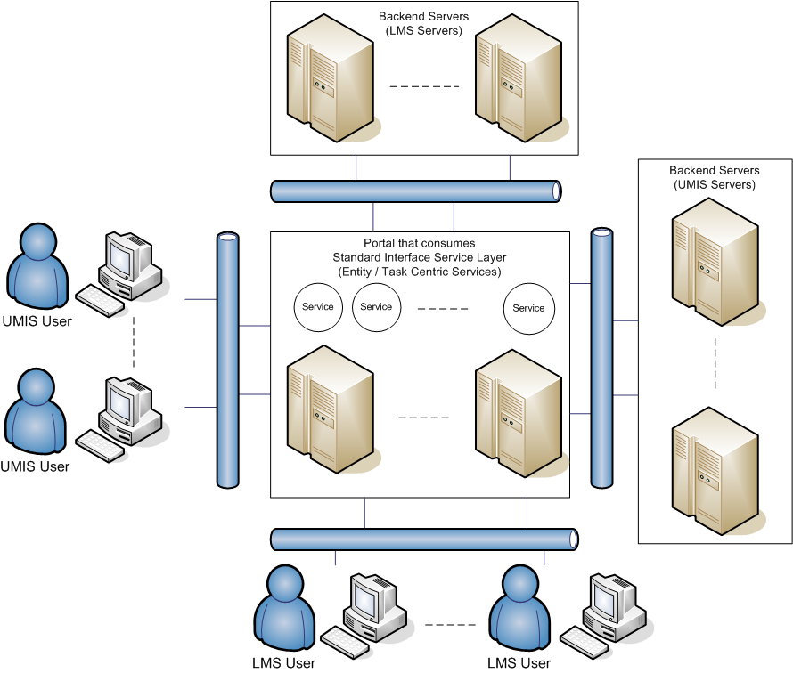

Figure: 2
Proposed Solution Presenting a Service Layer
as Intermediary between UMIS, LMS, and Users

EVALUATION OF PROPOSED SOLUTION

Evaluation of proposed solution includes Information Systems, and Pedagogical perspectives.

- Information Systems Evaluation: Figure: 3 presents architectural parameters that can be used in evaluating information systems. It is evaluator’s responsibility to determine the most valuable architectural aspects to be considered in the evaluation process (Fielding 2001). Information systems quality parameters evaluated in this paper are: Network Performance, User Perceived Performance, Integration and Interoperability, and Reusability. SOA enhances system overall security, replace ability, testability, and both hardware and software scalability (Erl 2005).

- Pedagogical Evaluation: Pedagogically, LMS shall enable universities and educational institutions to provide educational services in an easy, effective, and efficient manner. LMS providers and evaluators must be aware of pedagogical effects that will affect instructors and students. Current LMSs do not provide the required pedagogical effects (Duffy and Kirkley 2004). One of the reasons is technology limitations. SOA helped LMS to come over some of the technology limitations.

Information System Evaluation Quality Parameters
From information system perspective, quality parameters like performance, integration and interoperability, compliance, security, maintainability, analyzability, decomposability and modularity, testability, portability via replaceability and scalability, simplicity, modifiability, and reusability shall be addressed. A Comparative performance analysis study is presented to test SOA based systems user-perceived performance against non-SOA based systems.

Network Performance
SOA based systems relies heavily on messaging. It is clear that SOA based applications need to add extra headers to manage requests and responses in standard format. Header can be classified into two Static Header and Dynamic header. Static header is added once for every time the service is invoked while Dynamic header is added for every record contained within request or response message. Network Delay can be calculated using the formula (Kurose and Ross 2005):

Total Delay = Transmission delay + Propagation delay + Processing delay + Queuing delay Because processing and queuing delays are less than micro seconds, they are ignored and the formula becomes:

Total Delay = Transmission Delay + Propagation Delay Because the amount of transferred data within evaluation lab was static, Propagation delay is static, so the Total Delay becomes the value of Transmission Delay.

Transmission Delay = (M + N – 1) L / R

Where:

- M = no. of communication links
- N = no of packets
- L = packet size
- R = Transmission Rate

Transmission delay is affected by file size (F). In the previous formula F = N*L.
By analyzing data in the request and response messages, it is noticeable that there are three data categories:

- Static Header: This header occurs once for each service invocation no matter how many records in the request. There are 463 characters for one of the test headers.

- Dynamic Header (XML Tags): Those tags are the overload of requests and responses. Those tags are named by developer, so they are not static every time, but in the same test message there is 179 characters.
- Actual Data: Those are the record details to be inserted after invoking the Web service.
So, Total extra characters = Static Header + XML Tags. So, file size in SOA will be:
F_{SOA} = F + SH + RH * R
Where:
- F = total data size without headers
- SH = Static Header
- RH = XML tags required to represent a single record
- R = no of records

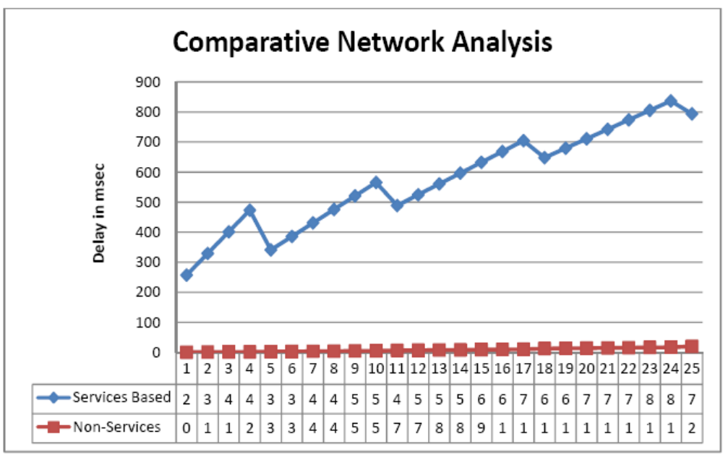
This formula depicts that added extra headers differs according to the no. of records to be handled, and differs from an application to another (because the header used to represent an author might be different from the one used to represent a book) so network performance differs from an application to another. Figure 3 presents a comparative network analysis between the services based system and non-services based system implemented in this case study. It is the system architect responsibility to decrease the transferred data over the network to the maximum extent (so decrease network delay) because it is noticeable that headers needed by SOA cannot be neglected easily.

Figure: 3
Comparative Network Analysis between Services
and Non-Services based System

User Perceived Performance
Web services are the main SOA enabler. It is expected that utilizing Web services within an application will affect User Perceived Performance. In order to understand the extent to which Web services affect User Perceived Performance, three different Library Management Systems (LIS) were implemented tested against the same data samples.

The three different LISs are Parameterized Query based LIS, Stored Procedures based LIS, and Services based LIS. While Parameterized Query based LIS SQL statements exist within the web pages and accesses database directly, Stored Procedures LIS highlights the separation between data layer and application layer by the presence of Stored Procedures as a middle layer in-between the portal and the databases.

The Portal consumes stored procedures to access the databases. The services based LIS presents the services layer in between the portal and database layer to present a standard based interface layer that consumes stored procedures and available for portals.
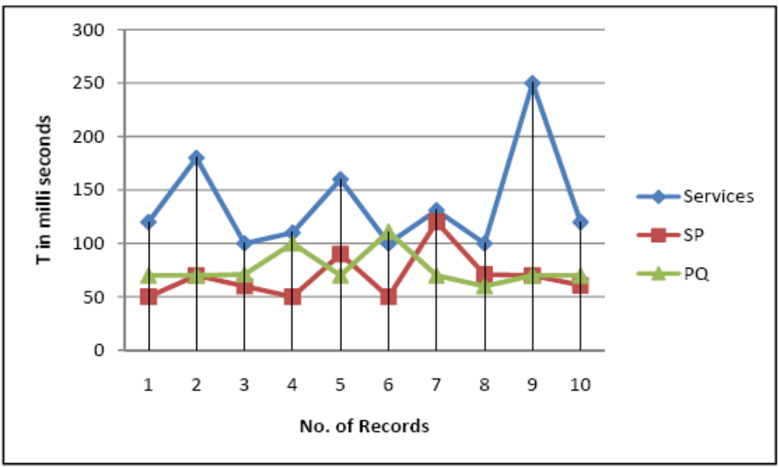
Figure: 4
Insert Performance Measures of the three LIS Architectures

Figure 4 illustrates statistics of the Insert process for the three implemented LISs. Table: 1 is a summary of the arithmetic mean and mode for each system. Services based LIS presented the highest arithmetic mean and mode values while Stored Procedure based LIS were the best for the insert operation.

Table: 1
Insert Operation Measurements Summary–
Measures are in Milli-Seconds per Record

Architecture | Arithmetic Mean | Mode
Service Based | 137.1 | 100
Stored Procedure Based | 69.2 | 50
Parameterized Query Based | 76.2 | 70

Figure: 5 presents the statistics of the Update operation followed by table 2 that displays summary of arithmetic mean and average of the same operation. Services based LIS is the lowest in performance compared to stored procedures and parameterized query based LISs. In the mean while, stored procedures based LIS is the best performance regarding the Update operation?

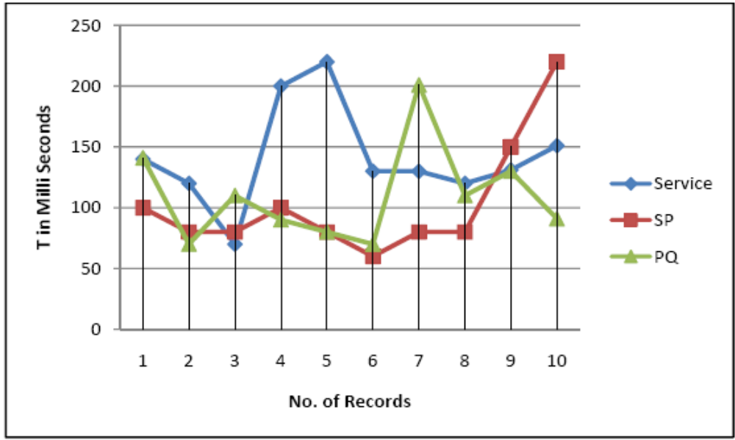
Figure: 5
Update Performance Measures of the three LIS Architectures

Table: 2
Update Operation Measurements Summary–
Measures are in Milli-Seconds per Record

Architecture | Arithmetic Mean | Mode
Service Based | 141.2 | 120
Stored Procedure Based | 103 | 80
Parameterized Query Based | 109.3 | 70

Figure: 6 presents statistics of the Select By ID operation of the three implemented LISs, followed by table 3 that summarizes the arithmetic mean and mode. Services based LIS is the highest in ranges. While arithmetic mean and mode depicts that parameterized query based LIS performance is better than the stored procedure based LIS, it is noticed that parameterized query based architecture was highly affected by the amount of data retrieved, and its performance was not within small ranges; not like stored procedure one.

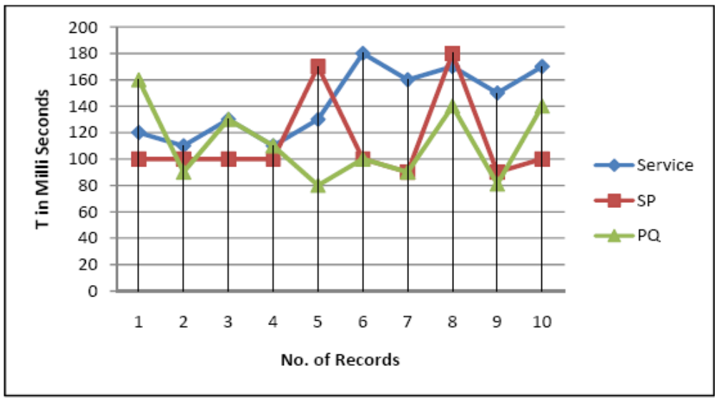
Figure: 6
Select By ID Performance Measures of the three LIS Architectures

Table: 3
Select By ID Operation Measurements Summary-
Measures are in Milli-Seconds per Record

Architecture | Arithmetic Mean | Mode
Service Based | 143 | 110
Stored Procedure Based | 113 | 100
Parameterized Query Based | 112.1 | 90

Figure:7 presents the total amount of time required by each of the three LISs to retrieve all data stored in the database, with no filter applied. Stored Procedures based LIS achieved the best time, services based architecture required time to retrieve the stored records exceeded the double time consumed by stored procedure based system, and parameterized query based system performance lies in between.

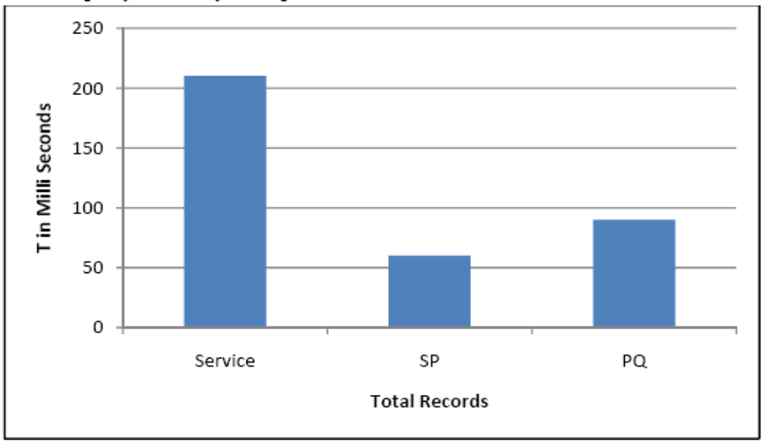
Figure: 7
Display All Performance Analysis of the three LIS Architectures

From the presented performance analysis and after evaluation of the three LISs, it is clear that the time consumed to perform the same operations using the services based LIS exceeds the time consumed to perform the same operation using either the stored procedure LIS, or the parameterized query one.

Integration and Interoperability
Systems can share their effects within a single operation via service level integration. Assessment Management System (AMS) did not have to access Student Affairs Information System database tables to retrieve and update student table data; instead, it just invoked the Update_Student service exposed. AMS includes a Take Assessment Process that needs interoperability between AMS and external systems as presented in paper (Riad and El-Ghareeb 2008). Without this interoperability, Mobile assessment would not have taken place at all. SOA utilization in the system gave the system capability to expose standard interfaces that act like sockets to be plugged in to connect systems.

Reusability
Reusability is achieved in the proposed architecture on two levels: Internal and External. Internal reusability distinguished the application capability to use the implemented service more than once without modification. This happened with the Update functionality, where it consumed Delete and Insert functions. Services were not written every time. External Reusability refers to the external systems that consumed the exposed internal services to achieve functionalities. CMS shared services with AMS and UMIS, and that reusability distinguished the advantages of SOA.

Pedagogical Evaluation
While integrating UMIS and LMS needed the SOA based system, pedagogical aspects are affected indirectly. No matter how mature LMSs become, there are more functionalities to be added.

- LMS was not affected; from the pedagogical point of view, by adopting SOA. SOA adoption facilitated integration of software agents within new proposed systems. Software agents have played; and still, important roles in e-Learning. Integrating software agents with Web services was presented successfully in proposed Course Management System (Riad and El-Ghareeb 2007) and Assessment Management System (Riad and El-Ghareeb 2008).
- Mobile assessment refers to the capability of conducting assessments via mobile devices. Mobile assessment relies on external services that are not part of the LMS. Integrating different external systems and services to be virtually part of the educational institution LMS is one of integration challenges. Mobile Learning (M-Learning) is an approach to e-learning that simply utilizes mobile devices, yet it can also be viewed as a quiet different learning experience. It is possible to force series of interactive SMS exchanges between learner and LMS to achieve completion of a task or goal. Learner will take part, and complete the task. M-learning has been used as a pre and/or post activity to other types of learning. Assessment for learning can be thought as one of the post learning activity that can be achieved via mobile phones. Mobile Learning was successfully implemented and the main enabler was SOA adoption.
- Unlocking Course Repositories via Automating the Discovery, Downloading, and Paying of Shared Courses was one of the pedagogical advantages gained by adopting SOA (Riad and El-Ghareeb 2007). One of the critical limitations of a newly established educational institution is the lack of available well prepared courses. It is more applicable to use widely available courses that might be higher in quality than preparing new courses. Current Course Management Systems (CMSs) do not exploit courses shareability. A SOA based CMS is proposed to highlight automated discovering and importing of courses maintained and managed by external CMSs. Educational institutions can increase Return-On-Investment (ROI) by selling courses.
- Digital Library contents are available to all LMS components to utilize, search within, and enrich the learning activity with valuable contents without the need to adopt new systems. SOA facilitated the integration between LMS components and Digital Library solution.

CONCLUSION AND FUTURE WORK

SOA adoption within e-Learning in the form of UMIS and LMS presented information systems’ advantages as well as pedagogical ones. It is clear that there is still more to be discovered and more advantages will become available upon adopting SOA in e-Learning. Evaluating Information System quality parameters highlighted the fact that SOA based architectures most fit between information systems as an integration facilitator, but when used to build the entire applications, it affects the system performance greatly.

Pedagogically, SOA has helped e-Learning achieve more than one goal. One of the critical limitations of a newly established educational institution is the lack of available well prepared courses. It is more applicable to use widely available courses that might be higher in quality than preparing new courses. Current LMS do not exploit courses shareability. Proposed SOA based LMS addressed this shortage, automated discovering and importing of courses maintained and managed by external LMSs. Proposed LMS facilitates integration between different LMSs in order to share resources of educational institutions. SOA facilitated integration between software agents that play an important role in educational institutions and Web services; that is the core of proposed SOA LMS. Also, integrating legacy systems and newly added systems is facilitated by SOA. M-Learning is enabled by proposed system. Mobile assessment is one of the M-Learning activities facilitated by proposed SOA based system. Mobile assessment relies on external services that are not part of the LMS. Integrating different external systems and services to be virtually part of the educational institution LMS is one of integration challenges. The capability to integrate the different digital library contents and make it available to different LMS components is a clear example of the SOA capabilities to integrate different and standalone system components and make them available to each other.

BIODATA and CONTACT ADDRESSES of AUTHORS


A. M. RIAD Head of Information Systems department in Faculty of Computers and Information Systems in Mansoura University. Graduated in Mansoura University from electrical engineering department in 1982. Obtained Master degree in 1988, and Doctoral degree in 1992 in Electrical Engineering. Main research points currently are intelligent information systems and e-Learning. http://www.amriad.com


Hamdy K. EL-MINIR Head of Communications Department in Misr Engineering and Technology Institute, Mansoura, Egypt. Associate Professor at National Research Institute of Astronomy and Geophysics, Helwan, Egypt. Graduated in Electrical and Electronic Engineering Department, Faculty of Engineering, Mansoura University, Egypt. Holds a Master Degree in Power Engineering from Faculty of Engineering, Mansoura University Egypt. Holds a Ph.D. in Electrical Engineering from Faculty of Electrical Engineering, Czech Republic, 2001. Currently, interested in Information Sciences. For contact: hamdy_elminir2@yahoo.com


Haitham A. EL-GHAREEB Associate Teacher; Information Systems Department, Faculty of Computers and Information Sciences, Mansoura city University, Egypt. Interested in e-Learning, Software Architecture; specially Service Oriented Architecture (SOA), and Business Process Management (BPM) and Business Process Management Systems (BPMS). Hold a Bachelor Degree (2004) and Masters Degree (2008) from the same faculty working on. Master thesis was entitled “Evaluation of Service Oriented Architecture in e-Learning”. It discusses closely the challenges, limitations, and opportunities in utilizing SOA in integrating different e-Learning and University Management Information Systems' Components; while maintaining an adequate pedagogical effects and capabilities of e-Learning systems. Currently, a PhD. student in the same faculty and working in “Supporting e-Learning with Adaptive and Intelligent Features”. Information about publications, activities, and personal blog are available at the Web site: http://www.helghareeb.net

REFERENCES

Britain, S.; Liber, O. (2008). ”A Framework for the Pedagogical Evaluation of Virtual Learning Environments”, JISC Technology Applications Programme.

Duffy, T. M.; Kirkley, R. J. (2004). Learner-Centered Theory and Practice in Distance Education, Lawrence Erlbaum Associates.

Endrei, M. (2004). “Patterns: Service Oriented Architecture and Web Services”, IBM RedBooks.

Erl, T. (2005).Service Oriented Architecture: Concepts, Technology, and Design, Prentice Hall.

Fielding, R. T. (2001). Architectural Styles and the Design of Network-based Software Architectures, Irvine: University of California.

Klims, C. (2007). “Portal Solutions for University Information Systems with the LMS integration”, EUNIS.

Kunkel, M., “From Stand-alone LMS to Integrated Systems”, September 2006,
http://project.bazaar.org/2006/09/15/from-stand-alone-lms-to-integrated-systems/ Retrieved on November 7, 2008

Kurose, J. F.; Ross, K. W. (2005). Computer Networking: A Top-Down Approach Featuring the Internet, 3/E , Addison Wisely.

Riad, A. M.; El-Ghareeb, H. A. (). “A Service Oriented Architecture to Integrate Web services and Software Agents in Course Management Systems”, Egyptian Informatic Journal, Cairo Unviersity, 2007, Vol. 8, Issue 1.

Riad, A. M.; El-Ghareeb, H. A. (2008). “A Service Oriented Architecture to Integrate Mobile Assessment in Learning Management Systems”, Turkish Online Journal of Distance Education – TOJDE, April 2008 ISSN 1302-6488 Volume: 9 Number: 2 Article 12.

